2020 Wittry Programming Contest

A couple of notes and hints as you compete in this contest.

* All programs will be compiled and tested using java 11.0.2.
* To score any points, ALL your program must compile with java 11.0.2

Every problem is worth 10 points, except for the following problems

* CubeIt is worth 13
* FunctionsGoneWild2020 is worth 16 points
* 08 Lies, damned lies, and (LieCalculator) is worth 12

This brings the grand total to 111 possible points.

* Note: problems are listed in alphabetically order with no regard to ease or difficulty of each problem

You will be given a Print out of all 10 prompts and a Flash Drive with three folders. The ‘prompt’s folder contains the prompts both as a word file and as a pdf.

The ‘Working folder’ and the ‘Team # java files’ Folder contain the java the files along with Junit test files. Use the Junit test files to make sure your files compiles.

The ‘Team # java files’ is the folder I will grade at the end. ALL files in the folder must remain in the Folder. In order to have your work graded**, ALL java MUST compile**. If just file does not compile, your program will score 0 on Stipulator. Please, only java files should be in the Folder. You may add helper classes and you may add helper method to any of the existing classes.

The ‘Working folder’ has been provided allowing you to work on/modify the java files without jeopardizing you score. I would suggest you work on the files in the ‘Working Folder’, and as you complete each class/java file, replace that the java in the ‘Team # java files’ Folder.

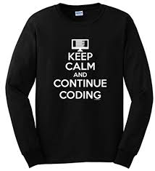At 12 PM, you are to bring me your Flash drive, I will copy the ‘Team # java files’ Folder to my folder where I will grade it with Stipulator.



And lastly – I hope you have a great time problem and solving, and please spread the word at your school and with friends how much fun you had today!